**Lesson01 How to Install ffmpeg on Windows 10**

**Notes: -**

**1-on the below URL** [**https://ffmpeg.zeranoe.com/builds/**](https://ffmpeg.zeranoe.com/builds/) **we download the ffmpeg exe file**

**2-on the C: we extract and paste the file**

**3-on the computer management 🡪 Environment variables add new property in Path**

**C:\ffmpeg\bin**

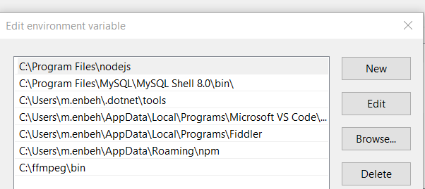

**4-make sure that the .exe is applied**

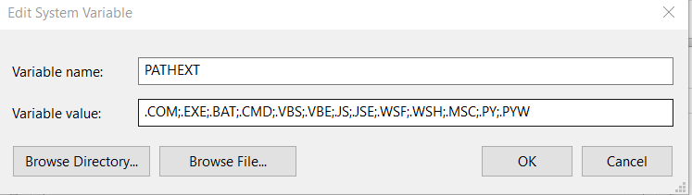

**5-on command prompt type the following command**

**ffmpeg //to check for the ffmpeg is applied**

**ffmpeg -i 1280.mp4 -vf scale=4800:-1 -c:v libx264 -qp 16 new1.mp4**

**//to change the video frame width and height**